Interest Groups
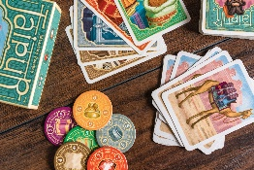
Board Games
We play Sequence, Quirkle, Upwords, Rummikub, Dobble, Uno and many card games. Also any games members bring along.
Venue: The Boathouse, Hythe Marina, Time: 2pm 3rd Tuesday of the month

Book Club
Members recommend books to read and then discuss. Venue: members’ homes, Time: 2pm on first Tuesday of the month

Canasta

A devilish game of strategy, played in teams of 4 or 6. After one session you’ll know how to play then it’s a lifetime of fine tuning how to wipe out your opponents! Come and join us, never a dull moment!

Venue: Hythe Community Centre, Time: 2pm – 4pm, 1st and 3rd Thursday of the month

Coffee Mates – WhatsApp group
If you are going to Hythe or anywhere locally and would like to stop for a coffee, just post it on WhatsApp and have an informal chat with others who can make it at a café.

Discussion
Discussion on various subjects chosen by the group.
Venue: Convenor’s house Marina Village Time: 10am 2nd Monday of the month

History
We use books and the Internet to research something historical that interests us then talk to the rest of the group about it. We occasionally have walks and outings too.
Venue: St Andrews Centre, Dibden Purlieu, Time: 10am 3rd Monday of the month. Cost currently £2 per meeting
Lunches Out
We meet on various days in the 1st week of the month at local or easy to get to locations. The group is restricted to a maximum of twelve to keep it very sociable and ensure a warm welcome for all that attend.
Petanque
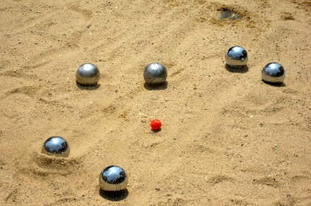
The aim of the group is to enjoy themselves whilst meeting friends and getting some exercise in the fresh air. Rules of Petanque are easily learned so open to all. No cost but the landlord likes us to buy a drink.
Venue: The Old Mill at Hardley, Time: Monday, 2pm -4pm weekly unless weather causes a cancellation.

Pickle Ball
Pickle ball is a paddle sport that combines elements of tennis, badminton, and ping-pong. It is played on a badminton-sized court with a slightly modified tennis net, where players use paddles to hit a plastic ball between them.
Played as both singles and doubles, it's a very social game where you can meet new people and play with friends and family.

Play Reading
We meet in members’ houses to read a variety of plays, each taking a part. Nobody takes it too seriously and we often have a good laugh. After the reading we discuss plot, characters etc. and have a cup of tea.

Time: 2pm on 4th Tuesday of the month. Small cost.

Quizzing
Variety of quizzes and possibility of word puzzles
Venue: Hythe Community Centre Time: 4th Monday afternoon of the month. Small cost for room hire


Singing for Fun
You need little experience of singing, there are no auditions. We sing popular songs, ordinary songs that people like to sing. We stop halfway to have tea/coffee and biscuits.
Venue: Hythe Community Centre Time: 2pm on 1st and 3rd Monday in the month
Social Cycling
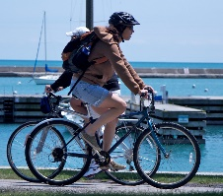
You need a bike (push or electric), and a good sense of humour. There is a leader at the front and someone at the rear to ensure no one gets left behind. Most rides are from home, mostly on cycle paths with some roads, but some start further afield and car transport is required. Routes vary from 10 miles upwards but there is always a coffee stop planned in. Time: twice a month and dependent on weather
Trail Walking
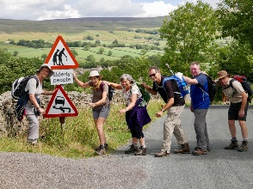
We walk long paths like the Clarendon Way and the Castlemain trail. These walks cover a number of walking days and we share transport to get there. We have also walked parts of the South Downs Way, Cotswold Way, staying away for a few days.
Walking 3-5 miles -Smilers
This friendly group aim to walk 4 miles at a comfortable pace of about 2 miles an hour. Coffee stop enroute or at the end
Time: Twice a month on varying days of the week. Usually local from Forest car parks.
Wine Appreciation
For members who are interested in tasting and learning about different wines around the world.
Venue: member’s house, Time: monthly in the evening
This group is currently full due to restricted space at venue. If enough members (6) are interested we can start another group, so let the Groups Co-ordinator know if you are interested.

If you would like more information about any of these groups, please contact
hdu3agroups1@gmail.com. I will happily pass on your details to the Group Convenor and you can join them for a guest session.

