Hythe & Dibden Newsletter No.2 
Dear Members,
The weather is certainly beginning to get cooler and time to discard our summer clothes and think about putting on the central heating. The recent wet weather has helped the grass to recover and become green again and to grow rapidly. The leaves are beginning to show signs of autumn, and I have read due to the long hot dry summer, the colours should be spectacular this year, due to the high sugar content absorbed into the leaves and protecting them from the sun.

The September speaker meeting attendance was much better, as in August the numbers attending were low, due to holidays or the hot weather! I’m unsure but I hope the numbers will pick up over the coming months.
Maureen works hard to find speakers to interest us all and we have very good ones coming up for the next 2 months.
13th October, Barbara Inkson - A Quick Tour of The Criminal Justice System
10th November, Brian & Jacquline Sutton – Dickens, the best & the worst!
We will then be preparing for Christmas; planning is already being arranged by the committee for Monday 8th December. We hope many of you will be able to join us in the afternoon and we will let you know all about the event in good of time.

Our new Group Convener Vanessa has been coming up with great new ideas to increase our interest groups. The Curry Club now has 8 members and although it hasn’t taken place yet arrangements are under way for our first meeting. The Quizzers afternoon will begin in October and a few more people signed up in our September meeting, so it is looking good.

The Craft Along Group where members can bring along their own crafts e.g. Knitting, Crochet, Sewing, Embroidery, Painting, Card making etc. do come along and join in with others for 2 hours each month to pursue your interest and enjoy a coffee with cake or biscuits and a chat.


I have only been able to visit a few interest groups, but I hope to arrange more over the next few months. The Wine Group, which I already belong to, went on a very informative tour to The New Forest Fruit Farm where Sandy Booth, is the passionate owner and he has ventured into producing his own wines, bringing Beaulieu vines back to life with excellent results and we all enjoyed tasting the 4 varieties he is already making, and they can all be bought locally.
The wine tour with Brian our convener, also Jan and Di looking like strawberries!
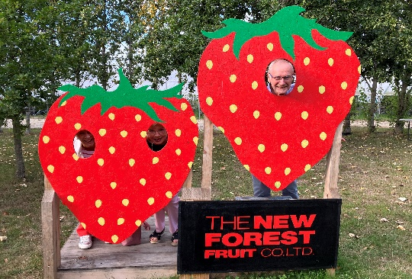 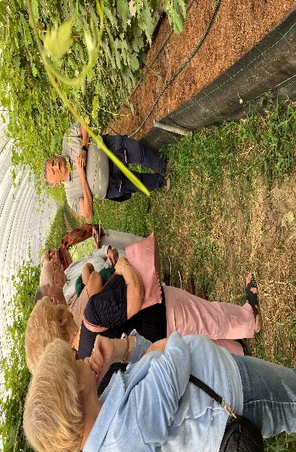 Everyone paying attention to Sandy and then to the tasting, a good time was had by all of us and we could aslo purchase the bottles of wine to enjoy at home.
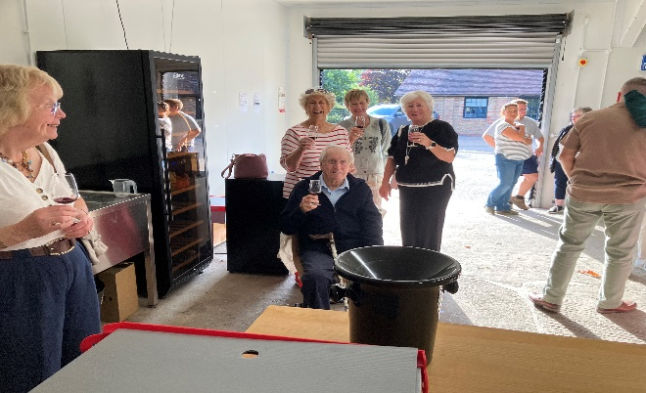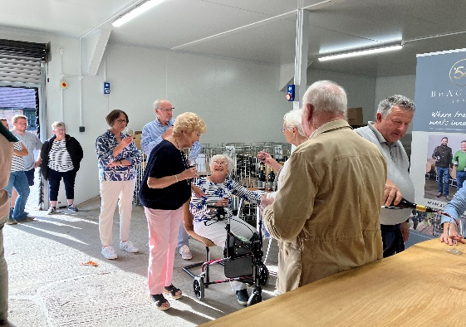
We then went onto Di Hobson’s home for an excellent supper provided by Jan and Di. Thank you, for a very well organised evening.
I have joined The Games Group, which meet at the Boathouse on the third Tuesday afternoon 2-4 o’clock after my visit to them, and I especially like the games played – Qwirkle, Sequence, Rummikub and finishing off the afternoon with Uno, when time allows.
The Playreading group had already started reading the play at the previous meeting, when I visited, so I missed the beginning, I was given a part to join in. Not realising there was a twist in the tale, and I ended up being the murderer, it was good fun.

I certainly won’t be able to become a member of all the groups I am going to visit, as I would end up with no spare time or being able to pursue any of my other club involvements.
A funny quip for this month – which appealed to my sense of humour:
The only thing I take seriously in the newspaper nowadays is FISH & CHIPS and I even take that with A PINCH OF SALT!

I would like to have articles and photographs from our interest groups to share with our members, so they can enjoy and join in all that u3a in Hythe & Dibden has to offer.
As members of  learn, laugh, live you can connect with others locally, but you can also look to see what is on offer across the UK, recipes, podcasts, learning languages – they even offer Welsh. Learn Online activities, competitions, maths challenge, air fryer community for tips
If you decide to find out more, click on the menu IN the right-hand corner and scroll down to Login this is the members area.
 website is free for members at u3a.org.uk
You will need to create an account to view the Members Area with your name, Username - email address, password and your u3a group Hythe and Dibden.

Mary Fenn
3rd October

