Hythe & Dibden Newsletter No.3
Christmas is fast approaching and I hope to see many of you at our Christmas Celebration next week. No doubt many of you are very busy with all the preparations leading up to Christmas, making puddings, cakes, mince pies and buying all those goodies we eat at Christmas. Hythe had a busy day on Saturday for the Mistletoe Fayre and with all the lights and tree lit, it is looking very Festive. People have already been putting up their Christmas light on their homes, unfortunately, I am not that organised yet and although it is Advent, I wait until nearer to Christmas to put up my decorations. I have sent the cards to family and friends abroad, although many people are now giving donations to charity as the costs keep rising but I do like having cards, especially keeping in touch with friends that I don’t see so often.


I receive a number of emails from the trust in London, with monthly updates about the online groups and activities. The Southern Area Network Group also keep in regular contact and are researching the need for Welfare Officers for each u3a and we will hear about it in the future.

I went to the Boathouse on the Marina with the Lunch Group, where 12 of us met to enjoy good food and have a friendly chat, although it went very quiet after our meals arrived as everyone was busy eating and they have great views, especially in the good weather.
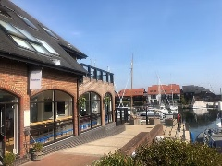
I think I may start the diet after Christmas with all the meals that I’m going to be eating.

I have managed to visit a few other groups as well. I hosted the first new Craft Along for a very enjoyable morning and we were so busy, the time went by really quickly. There was Knitting, Crochet and card making, getting ready for Christmas. I think I might give making gift tags a go, ready for Christmas, more members welcome.



The Singing Group was good fun with plenty of banter & laughter, you soon recognise the tune, if not all words. A variety of hits from Elvis, Beatles, Petula Clark, Abba a good mix I didn’t always manage to keep to time and my tuning could also have been off on a few of the notes – not all Welsh people can sing! Andrew and Jackie have a good variety and singing certainly makes you feel better in yourself as it was such a happy group.

The History Group was really interesting, as Vanessa Daley gave a talk about the ‘Dollar Princesses’, wealthy Americans who wanted their daughters to marry into the British aristocracy, unfortunately not all these arranged marriages were successful.
The convener Tim has contributed to this newsletter, to help me fill a few pages! Thank you, Tim, I really appreciate it.
History Group 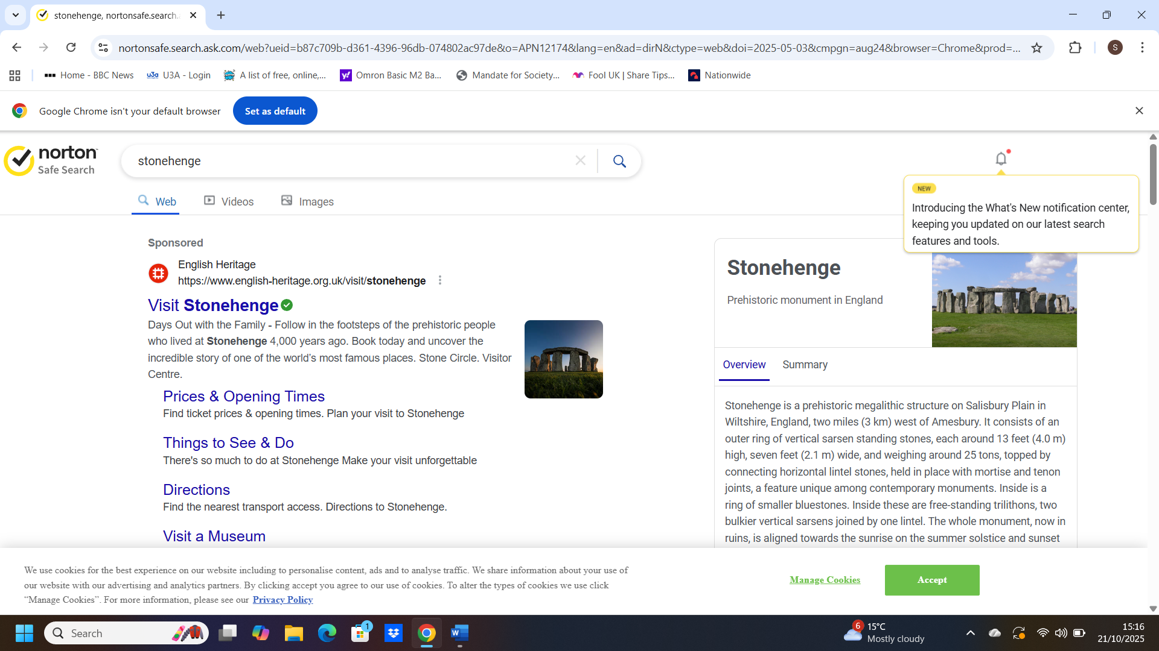

The Oxford dictionary defines history as “The academic study of the past of the human race”.
The H&D u3a History Group doesn’t really do “academic study” but I guess you could argue that we embody “the past”, and I think it’s a very long time since any of us “raced”. But let’s not get too fussy about these things.
We have a monthly get together at St Andrews Centre (full details on the website) when we spend an hour or so listening to one or two members giving a relaxed talk on just about any historical subject which is of interest. It’s also an opportunity to do a bit of catching up, and to have a cup of tea or coffee and a biscuit. And all for £2.00 per session.
A sample of the subjects we’ve covered since we started in 2017 includes The Beaulieu Rails, The Victorian Era, Crown Prince Rudolf of Austria, The Missions of San Antonio, The Barker Mill Family, The Easter Uprising 1916, the Red Cloud Wars, Emma of Normandy, The Royal Pavilion Brighton ….. and dozens more covering British history, European topics, and tales from US history.
We learn a bit, we laugh a bit, and we live to tell the tale.
Tim Parsons, History Group Convenor

The Curry Group has met twice and ate locally at Forest Spice and then The Indian Kitchen, everyone chooses their own menu, so various heats according to your palate. We now have 12 members and if it continues to grow, we may need to start another group. Booking in some restaurants is restricted, so 12 is a good start. Next month we are going to try the buffet so a variety of dishes can be sample

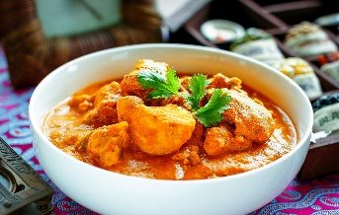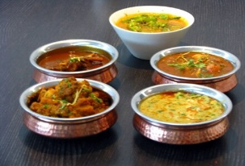
This Photo by Unknown Author is licensed under CC BY-SA-NC
This Photo by Unknown Author is licensed under CC BY-SA

It is pleasing to see many of the groups are well supported and as time goes on, we will try and introduce a few more. Vanessa has come up with great ideas and is always open to suggestions.
2026 Speakers
12th January Dr. Sohail Husain ‘’One Family’s Incredible Story Part 2’’
9th February Jennie Glennie ‘’The Ministering Angel’’
9th March John Piman ‘’The Role of the Dame in Pantomime’’
13th April Alan Skinner ‘’1338 and all that – Tudor Southampton’’
May 11th John Sherbourne ‘’The Life & Music of Cole Porter’’
June 8th ‘’ The Realm of the Polar Bear’’
With best wishes for Christmas and a Happy New Year 2026
from
Mary and all the committee

from Mary & all the committee


